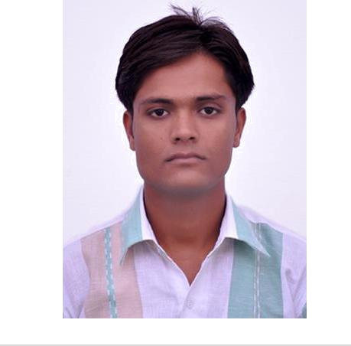

Technical Skills
Drafting and Annotation 3D Modelling and Detailed Drawing
Assembling of Components on both Solid Works, Catia and Creo 2.0 Software
Drawing, Developing and Assembling of a Part in SolidWork
Having knowledge of ARTIOS CAD

MAHENDRA KUMAR

DESIGN ENGINEER

Result-driven professional with a verifiable track record targeting new projects in the domain of Design Engineering.
yadavmahendra0895@gmail.com | +91 7023988442

Profile Summary
Focused professional with over 2.5 year of industrial exposure in Design

Engineering using AutoCAD and SOLIDWORKS SOFTWARE
Comprehensive knowledge in detailed engineering & 3D drawings, focused research, development, product & design
Proven skills in maintaining the documents as per quality standards, creating & interpreting engineering drawings and designing & developing new products in conformance to pre-defined technical specifications
Knowledge of developing & implementing the quality systems, process design, reading P&ID to meet the quality standards
Achieved 2nd position in B.Tech. Mechanical Branch
Effective in providing technical inputs for detailing methodologies & coordinating for reducing rejection levels by making effective utilization of man, machine, method towards attaining client satisfaction; possess excellent knowledge of AutoCAD drawings
Capabilities in coordinating project with cross-functional coordination & on time execution; excellent communication & interpersonal skills with proven skills in resolving complex issues

Career Timeline
- B.Tech(Mechanical Engineering from S.M.E.C. Neemrana, RTU,Kota)
- Professional in Product Design and Development from CADD Centre, Rewari
- Previously worked in Ganges Internationale pvt. Ltd.
- Currently working in Supra Craft And Packaging Pvt. Ltd.

Core Competencies

Detailed Engineering Drawing Development
Product Development Technical Support
Testing & Compliances Documentation & Reporting

Organizational

Experience

Mechanical Design Engineer Sep’15 to April’ 2017
Ganges Internationale Pvt. Ltd., Delhi
SENIOR Design Engineer April’17 to Present
Supra Craft And Packaging Pvt. Ltd , Bhiwadi

Key Result Areas:
- Study of all packing box style and design corrogated box
- Having Plotting software “Cut Centre” Knowledge and Plotting machine operation knowledge
- Having Good knowledge of SOLID WORK AND ARTIOS CAD Ssoftware
- Study of all MMT structure parts in AutoCAD, SOLIDWORK

Certifications

IT Skills

Academic Details
Drew the complete assembly of MMT structure in AutoCAD
Assisted in estimating new product development requirements and costs; analyzed & produced the technical requirements and recommended design modifications based on client requirements
Created layouts, designs, drawings & documentation and performing relevant modifications in the same; managed the processes of research, design, testing & introducing production of entire line of products
Troubleshoot all technical problems; conducted various tests & inspections to ensure that products developed were in compliance with pre-set quality specifications & customer requirements
Conducted periodic checks & tests to ensure performance of various samle.

Highlights:
Having Knowledge of Corrogation Field.Discussed drawings for new product
Having good knowledge of part modeling, assembling and drafting and annotation

Diploma in AutoCAD (2D & 3D) from CADD Centre, Rewari
Duration: 3 months

Professional in Product Design [CREO 2.0 (PRO/E 4.0), Solidworks & CATIA] from CADD Centre, Rewari in 2017 with A Grade

Duration: 8 months
product development with the teachers for executing designing projects
CATIA
AutoCAD (2012, 2013 & 2015)
SolidWork (2013 & 2017)
CREO 2.0
PRO/E 4.0,ARTIOS CAD
Operating Systems: Windows XP / 7 & 8
Computer Fundamentals, Microsoft Office & Internet Applications
B.Tech. (Mechanical Engineering) from S.M.E.C. Neemrana, RTU, Kota in 2015 with 76%
HSC from R.B.S.E., Ajmer in 2011 with 78% SSC from R.B.S.E., Ajmer in 2009 with 78%


Skill Set

Personal Details

Date: 16.06.2018

Change | Collaborator | Communicator | Planner | Thinker
Agent |  | Communicator | Planner | Thinker

Date of Birth: 15th August 1995
Languages Known: Hindi & English
Address: Hamjapur, Behror, Alwar - 301020, Rajasthan

Signature
Mahendra Kumar

